**Project 2**

**How to Create the new EC2 instance using AMI**

**Creating image:**

Steps:

1. To create image using AMI, go to EC2 and click on instances.
2. Select the instance that is created before and click on action.
3. In action, select image and template. In image and template, select create images.
4. Give name as anu-server-backup and description to the instances.

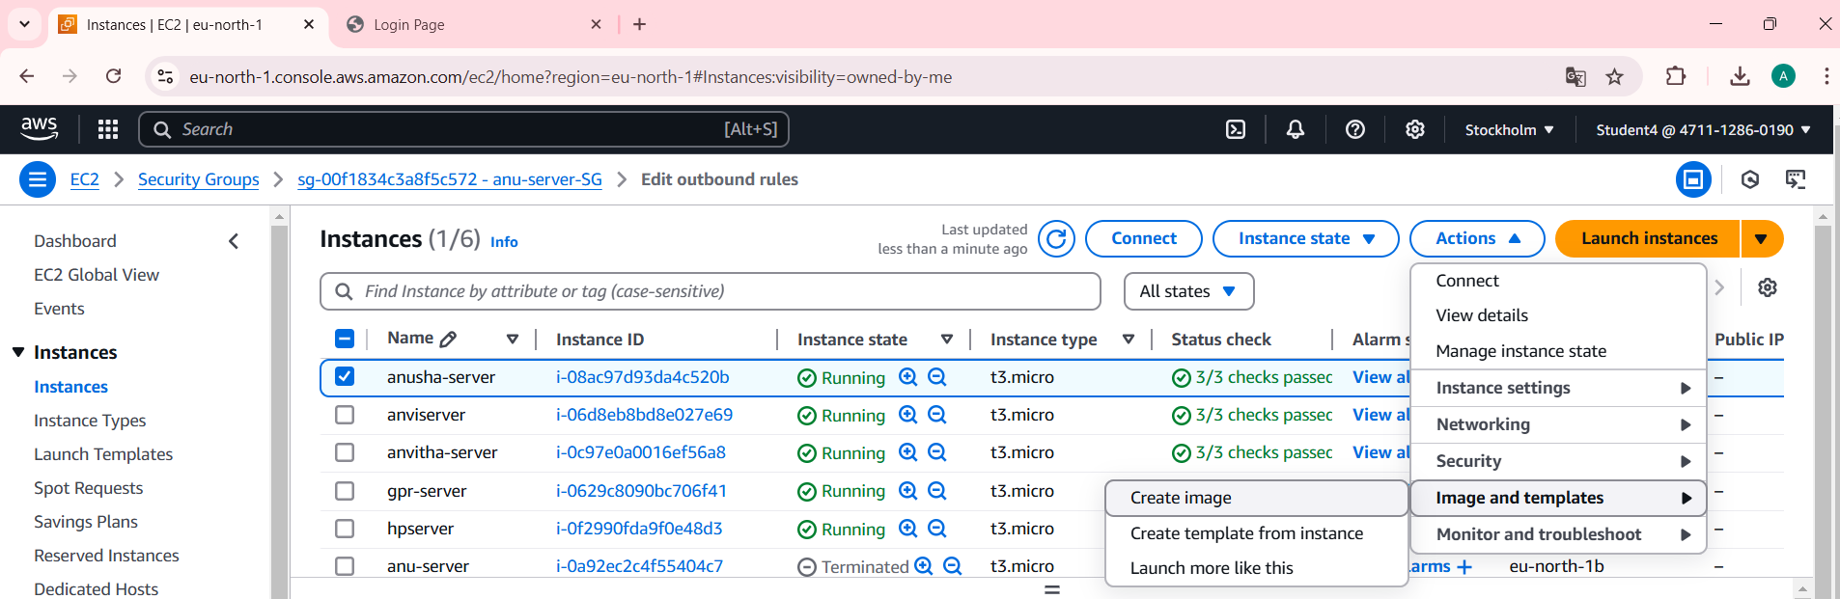

**AMI summary:**

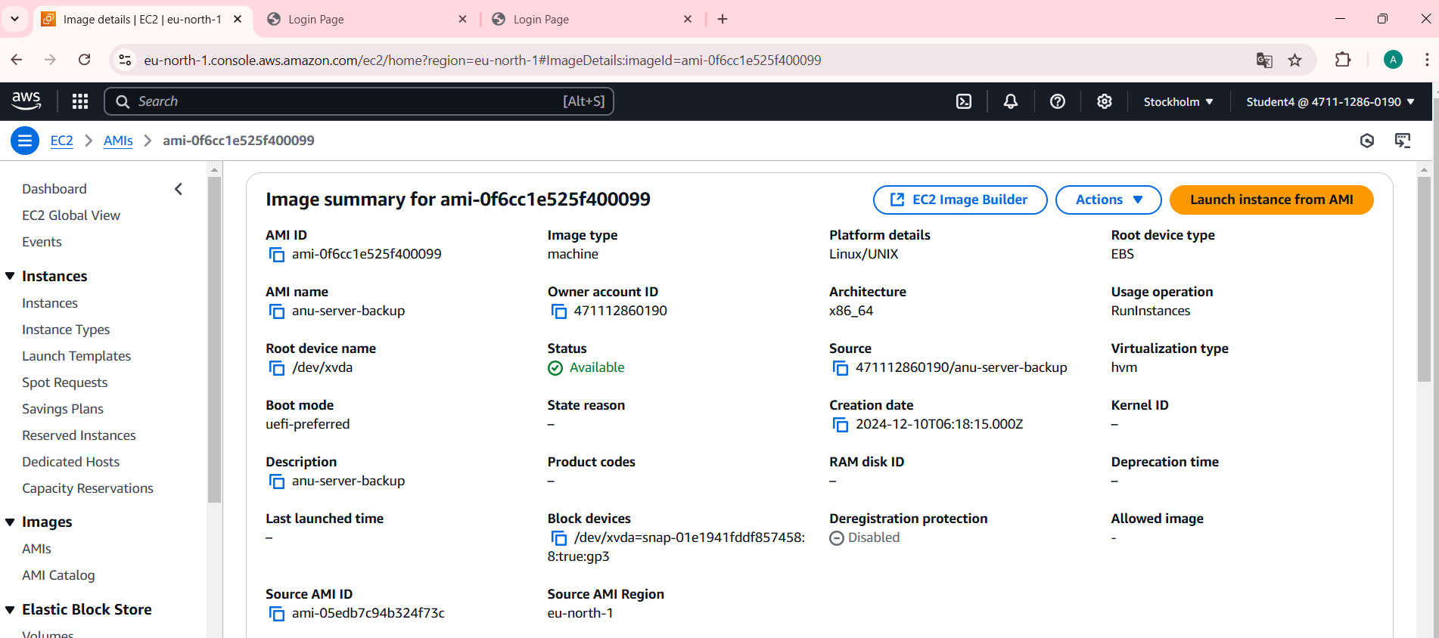

**After launching the backup server:**

Steps:

1. Click on backup server that is been created, copy the public IP address and paste it on browser.

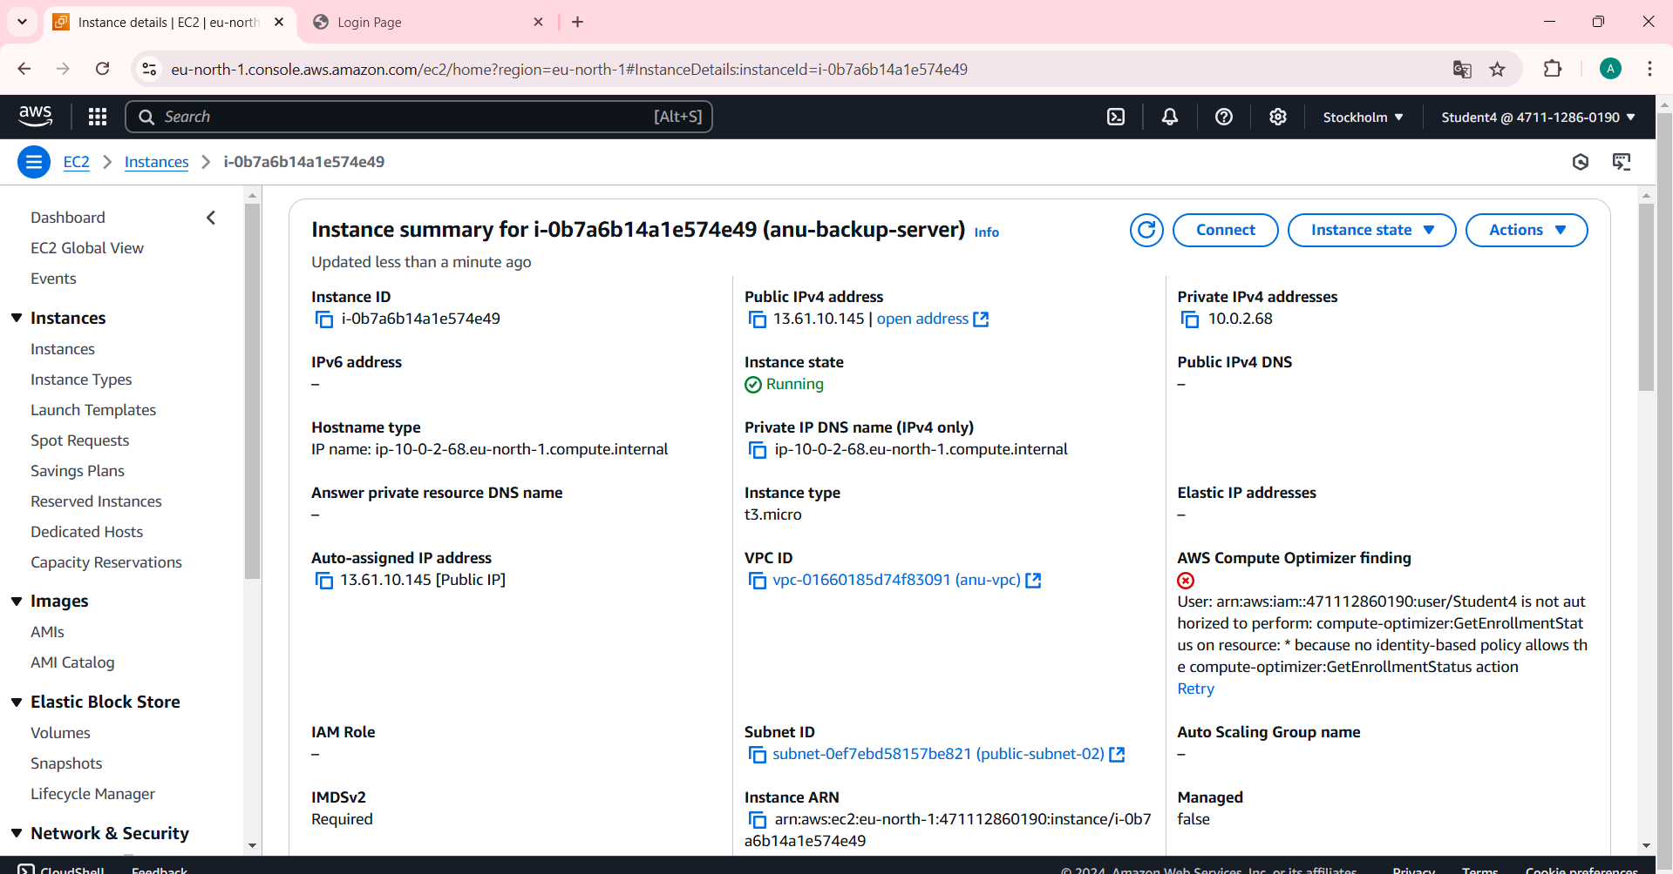

Final Result:

